ResumenNumericoOdis.R

apalmad

2021-01-10

########################  
#cargar las librerias  
########################  
library(readxl)  
library(ggpubr)

## Loading required package: ggplot2

library(dplyr)

##   
## Attaching package: 'dplyr'

## The following objects are masked from 'package:stats':  
##   
## filter, lag

## The following objects are masked from 'package:base':  
##   
## intersect, setdiff, setequal, union

#setear directorio  
setwd("C:/Users/apalmad/Desktop/Analiza tus Datos/Bloque 2/Empieza con tu Software")  
  
######################  
#leer datos  
######################  
datos <- read_excel("espalda-para-R.xlsx")  
  
#modifica tabla de datos  
diffodi <- datos[,9] - datos[,10]  
names(diffodi) <- "diffodi"  
datos <- cbind(datos,diffodi)  
df <- datos[,c(9,10,12)]  
  
############################  
#describir los datos  
#estadisticos descriptivos odi mes 0, odi mes 1, dif oddi  
############################  
ResumenNumerico <- t(do.call(data.frame,  
 list(mean = apply(df,2,mean),  
 stddev = apply(df,2,sd),  
 mediana = apply(df,2,median),  
 iqr = apply(df,2,IQR),  
 Min = apply(df,2,min),  
 Max = apply(df,2,max),  
 Rango = apply(df,2,max) - apply(df,2,min),  
 Cuartil1 = apply(df,2,quantile,prob = c(0.25)),  
 Cuartil3 = apply(df,2,quantile,prob = c(0.75)),  
 N = apply(df,2,length),  
 ErrStandard = apply(df,2,sd) / sqrt(apply(df,2,length)),  
 IC95MediaLower = apply(df,2,mean) - 1.96 * (apply(df,2,sd) / sqrt(apply(df,2,length))),  
 IC95MediaUpper = apply(df,2,mean) + 1.96 * (apply(df,2,sd) / sqrt(apply(df,2,length))),  
 Varianza = apply(df,2,var),  
 Suma = apply(df,2,sum))))  
ResumenNumerico

## ODI Mes0 ODI Mes1 diffodi  
## mean 6.415600e+01 39.626500 24.529500  
## stddev 1.411508e+01 17.443518 14.305644  
## mediana 6.540000e+01 36.150000 24.150000  
## iqr 1.950000e+01 27.125000 33.350000  
## Min 2.520000e+01 3.600000 5.000000  
## Max 9.390000e+01 82.900000 45.000000  
## Rango 6.870000e+01 79.300000 40.000000  
## Cuartil1 5.467500e+01 27.300000 9.950000  
## Cuartil3 7.417500e+01 54.425000 43.300000  
## N 2.000000e+02 200.000000 200.000000  
## ErrStandard 9.980868e-01 1.233443 1.011562  
## IC95MediaLower 6.219975e+01 37.208952 22.546839  
## IC95MediaUpper 6.611225e+01 42.044048 26.512161  
## Varianza 1.992354e+02 304.276329 204.651437  
## Suma 1.283120e+04 7925.300000 4905.900000

# GRAFICOS solo la varible diff odi sin agrupar  
hist(datos[,12],main="Hist Diff Odi")

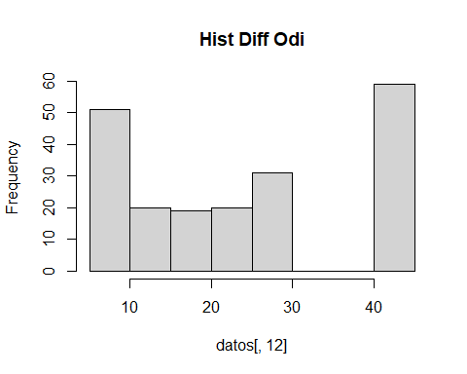

boxplot(datos[,12],main = "Box Plot Diff Odi")

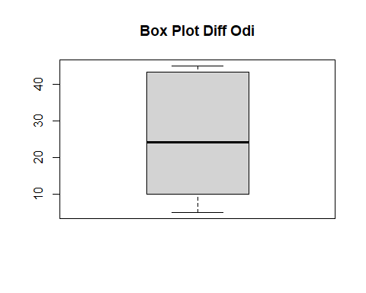

grupoconvencional <- datos[,11] == "Convencional"  
   
df <- datos[grupoconvencional,c(9,10,12)]  
ResumenNumConven <- t(do.call(data.frame,  
 list(mean = apply(df,2,mean),  
 stddev = apply(df,2,sd),  
 mediana = apply(df,2,median),  
 iqr = apply(df,2,IQR),  
 Min = apply(df,2,min),  
 Max = apply(df,2,max),  
 Rango = apply(df,2,max) - apply(df,2,min),  
 Cuartil1 = apply(df,2,quantile,prob = c(0.25)),  
 Cuartil3 = apply(df,2,quantile,prob = c(0.75)),  
 N = apply(df,2,length),  
 ErrStandard = apply(df,2,sd) / sqrt(apply(df,2,length)),  
 IC95MediaLower = apply(df,2,mean) - 1.96 * (apply(df,2,sd) / sqrt(apply(df,2,length))),  
 IC95MediaUpper = apply(df,2,mean) + 1.96 * (apply(df,2,sd) / sqrt(apply(df,2,length))),  
 Varianza = apply(df,2,var),  
 Suma = apply(df,2,sum))))  
  
  
ResumenNumConven

## ODI Mes0 ODI Mes1 diffodi  
## mean 63.932673 51.596040 12.3366337  
## stddev 14.225654 14.193632 5.4300409  
## mediana 67.100000 54.400000 10.0000000  
## iqr 16.400000 16.800000 8.3000000  
## Min 25.200000 20.200000 5.0000000  
## Max 90.200000 82.900000 24.9000000  
## Rango 65.000000 62.700000 19.9000000  
## Cuartil1 55.800000 43.300000 8.1000000  
## Cuartil3 72.200000 60.100000 16.4000000  
## N 101.000000 101.000000 101.0000000  
## ErrStandard 1.415505 1.412319 0.5403093  
## IC95MediaLower 61.158283 48.827894 11.2776275  
## IC95MediaUpper 66.707064 54.364185 13.3956398  
## Varianza 202.369222 201.459184 29.4853446  
## Suma 6457.200000 5211.200000 1246.0000000

grupoavanzado <- datos[,11] == "Avanzado"  
  
df <- datos[grupoavanzado,c(9,10,12)]  
ResumenNumAvanzado <- t(do.call(data.frame,  
 list(mean = apply(df,2,mean),  
 stddev = apply(df,2,sd),  
 mediana = apply(df,2,median),  
 iqr = apply(df,2,IQR),  
 Min = apply(df,2,min),  
 Max = apply(df,2,max),  
 Rango = apply(df,2,max) - apply(df,2,min),  
 Cuartil1 = apply(df,2,quantile,prob = c(0.25)),  
 Cuartil3 = apply(df,2,quantile,prob = c(0.75)),  
 N = apply(df,2,length),  
 ErrStandard = apply(df,2,sd) / sqrt(apply(df,2,length)),  
 IC95MediaLower = apply(df,2,mean) - 1.96 * (apply(df,2,sd) / sqrt(apply(df,2,length))),  
 IC95MediaUpper = apply(df,2,mean) + 1.96 * (apply(df,2,sd) / sqrt(apply(df,2,length))),  
 Varianza = apply(df,2,var),  
 Suma = apply(df,2,sum))))  
  
  
ResumenNumAvanzado

## ODI Mes0 ODI Mes1 diffodi  
## mean 64.383838 27.415152 36.9686869  
## stddev 14.070070 10.677187 8.7150075  
## mediana 62.200000 28.900000 43.3000000  
## iqr 21.000000 13.550000 17.1000000  
## Min 29.500000 3.600000 23.2000000  
## Max 93.900000 49.800000 45.0000000  
## Rango 64.400000 46.200000 21.8000000  
## Cuartil1 54.650000 20.750000 27.2000000  
## Cuartil3 75.650000 34.300000 44.3000000  
## N 99.000000 99.000000 99.0000000  
## ErrStandard 1.414095 1.073098 0.8758912  
## IC95MediaLower 61.612212 25.311880 35.2519401  
## IC95MediaUpper 67.155465 29.518423 38.6854336  
## Varianza 197.966879 114.002319 75.9513564  
## Suma 6374.000000 2714.100000 3659.9000000

###############  
# Descripcion de Diff Oddi Separado por Grupo  
##############  
descrixgrupo <- data.frame(cbind(ResumenNumConven[,3],ResumenNumAvanzado[,3]))  
names(descrixgrupo)[1] <- "Convencional"  
names(descrixgrupo)[2] <- "Avanzado"  
descrixgrupo

## Convencional Avanzado  
## mean 12.3366337 36.9686869  
## stddev 5.4300409 8.7150075  
## mediana 10.0000000 43.3000000  
## iqr 8.3000000 17.1000000  
## Min 5.0000000 23.2000000  
## Max 24.9000000 45.0000000  
## Rango 19.9000000 21.8000000  
## Cuartil1 8.1000000 27.2000000  
## Cuartil3 16.4000000 44.3000000  
## N 101.0000000 99.0000000  
## ErrStandard 0.5403093 0.8758912  
## IC95MediaLower 11.2776275 35.2519401  
## IC95MediaUpper 13.3956398 38.6854336  
## Varianza 29.4853446 75.9513564  
## Suma 1246.0000000 3659.9000000

############  
# Graficos  
############  
#Histogrmas & Box Plot para comparar tratamieto (grupo) para la variable diff oddi  
  
df <- datos[,c(12,11)]  
#HISTOGRAMAS  
hist(df[grupoconvencional,1],main="Histrograma Tratamiento Convencional")

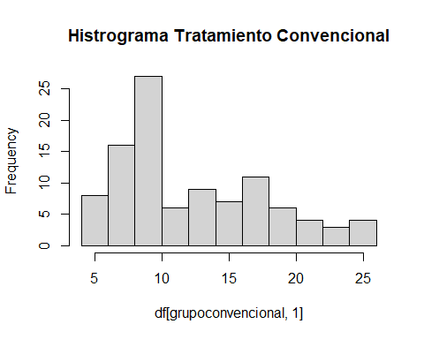

hist(df[grupoavanzado,1],main="Histrograma Tratamiento Avanzado")

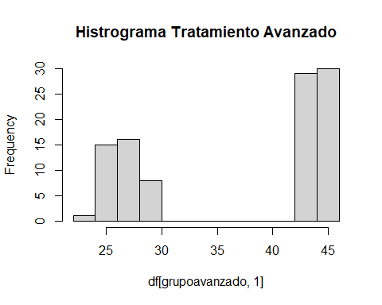

#BOX PLOT  
ggboxplot(df,x=names(df)[2],y = names(df)[1],color = names(df)[2])

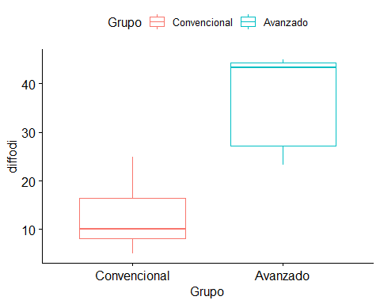

#graficos de puntos para ver la agrupacion por grupo tratamiento  
ggstripchart(df,x=names(df)[2],y = names(df)[1],color = names(df)[2])

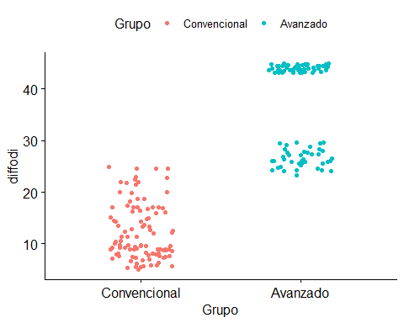

#Histograma de Densidad para Oddi Diff por grupo  
df <- datos[,c(12,11)]  
namevar1 = names(df[1])  
nameg1 = names(df[2])  
tipogrupos <- df %>%  
count(Grupo)  
  
   
  
  
ggplot(df,mapping = aes(x=df[,1],fill=df[,2]))+  
 geom_density(alpha = 0.2) +  
 xlab("Tratamientos ") + ylab("Densidad") +  
 theme_minimal() +  
 labs(title = " Histograma Densidad ",  
 subtitle = paste( "Tratamiento ",tipogrupos[2,1]," - ",tipogrupos[1,1]),  
 caption = "Data source: Analiza tus Datos",  
 x = "Tratamientos", y = "Densidad",  
 tag = "Primeros Programas con R") +  
 theme(plot.title = element_text(size =12, face = "bold", hjust = 0.5 ),  
 plot.subtitle = element_text(size = 9, hjust = 0.5),  
 plot.caption = element_text(size = 7),  
 plot.tag = element_text(size = 7),  
 axis.text = element_text(size=8),  
 axis.title = element_text(size=8,face="bold"),  
 legend.title = element_text(size = 8,face = "bold"),  
 legend.text = element_text( size = 7))+  
 guides(fill = guide_legend(title=nameg1))

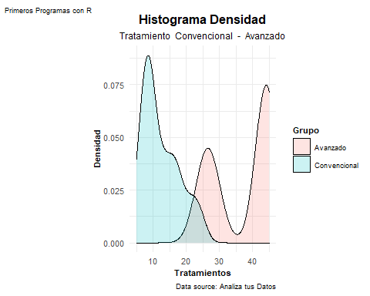

###################  
# Contraste de Hipotesis  
##################  
  
  
t.test(diffodi ~ Grupo, data = df)

##   
## Welch Two Sample t-test  
##   
## data: diffodi by Grupo  
## t = 23.935, df = 163.56, p-value < 2.2e-16  
## alternative hypothesis: true difference in means is not equal to 0  
## 95 percent confidence interval:  
## 22.59995 26.66416  
## sample estimates:  
## mean in group Avanzado mean in group Convencional   
## 36.96869 12.33663